User Guide: Sub-Ledger Closeout

| March-21 |

**Document Overview**

**Documentation Goals**

This documentation is intended to provide instruction for ***closing sub-ledgers each month in every affected module****.*

**Documentation Disclaimers**

* This document details the processes involved to close each of the sub-ledger modules.

Table of Contents

Overview 3

Closing Ledgers 3

Sub-Ledger Status 4

Sub-Ledger Closing 4

Close Sub-Ledgers 5

Sub-Ledgers 5

Payables 5

Payables Close Out Process 5

Purchasing 5

Purchasing Close Out Process 5

Work in Process 6

WIP Close Out Process 6

Order Processing 6

Order Processing Close Out Process 6

Bank Reconciliation 6

Bank Reconciliation Close Out Process 6

Accounts Receivable 7

Accounts Receivable Close Out Process 7

Inventory 7

Inventory Close Out Process 7

General Ledger 7

General Ledger Close Out Process 7

Prepare Monthly Close Out Package (Optional) 8

Configuration 8

Exhibits 9

zMessage60 9

Company File Maintenance 9

Period Status Screen 10

Period Pop Up Maintenance Screen 10

Sub-Ledger Close 11

# Overview

The business unit needs the ability to close a period and not allow any entries to be made into that period any longer. The *Sub-Ledger Close* process is designed to do the same for each active module integrated with the *General Ledger* such that modules can be closed and once closed, do not allow entries to be made into the closed period in that module. Closing the period will verify that all active modules are already closed.

Each module will have a close period function that will close that module and update the *General Ledger* that the module is closed thus assuring that no further entries will be permitted to be made into that module without re-opening the sub ledger.

## Closing Ledgers

The act of closing a month indicates that it is complete and accurate and that no additions or corrections are needed. Once closed you will still be able to run reports, as well as financial statements on the period, but you will no longer be able to post or make corrections to the month without re-opening a period. The last month closed is stored in the company file automatically when *General Ledger* *Monthly Close* is run.

The flexibility of the month-end close process allows you either to close all subsidiary ledgers at one time or to close each ledger independently from other ledgers. This allows you to restrict posting into those ledgers, while leaving other modules open for month-end activities (such as posting cost and other month-end adjustments and calculating allocations).

The *General Ledger* may not be closed in any month prior to the subsidiary ledgers being closed manually or automatically, so setting which ledgers are desired to be closed is important to have processes in place to prevent the numbers from changing and makes balancing the books easier.

Monthly closing is not required before moving on to another month. In the *GL Company File*, you specify the number of periods and date ranges for each and the status of each ledger. This allows you complete control over how far into the past and future entries may be posted. The date range of the periods is the controlling factor to allowing entries to be entered and processed. The *General Ledger* may be left open for as many additional months as desired.

The *General Ledger* can be kept open for the whole year to allow adjusting entries to be made if needed, however; if you close a sub ledger, that sub ledger will need to be opened again to allow transactions to be processed.

Most people prefer to close the *General Ledger* on a monthly basis (which is our recommendation) as re-opening a period is easy to do, but if you reopen a *General Ledger* period, you can re-open any sub ledger as well, but this is a manual process. Once a month is closed in the subsidiary ledgers or the *General Ledger*, no further entries may be made to the month.

Because of this flexibility, you may want to restrict access to this access to only the *Controller* or the *System Administrator*.

## Sub-Ledger Status

Each Sub Ledger has three (3) potential status values that control the entry of new items into that period. The values are as follows:

|  |  |  |
| --- | --- | --- |
| O | Open | This means the sub ledger is open for transactions. |
| C | Closed | This means the sub ledger is closed for transactions and no further entries can be posting in that sub ledger unless the status is re-opened. |
| A | Auto Close | This means the sub ledger will remain open until the *General Ledger* period is closed. |
|  |  |  |

## Sub-Ledger Closing

Sub ledgers normally will be closed in order as information becomes available in a sequence and that sequence should be applied to each sub ledger to close it properly and in balance.

The following outlines a suggested order of closing sub ledgers, if all sub ledgers will be closed, but sub ledgers can be closed in any sequence with the exception of the period close which must be run last.

Any sub ledgers that will not be closed, should be set to ***“A”*** (*Auto Close*) whereby they will close when the *General Ledger* is closed or turned off in ***“G”-“F”-“1”*** detail tab and will be ignored entirely.

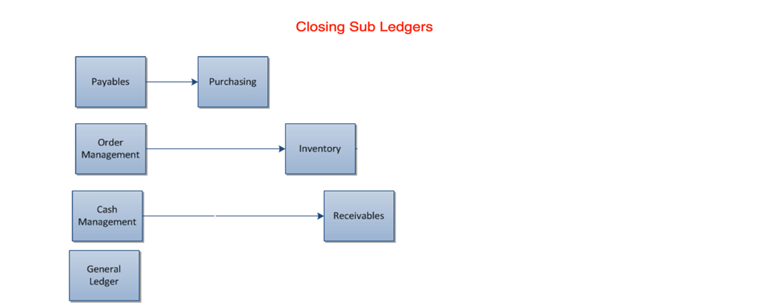

### Close Sub-Ledgers

When closing a sub ledger, a period close will be run that changes the status of the sub ledger to closed and will update the flag in the *Period* table. Only after all the sub ledgers that are set up to be closed are actually closed will the *General Ledger* period be able to be closed.  All transactions for previous periods must be processed before the period can be closed for that sub ledger.

Once a sub ledger is closed, no further entries for that period (Or date range in that period or any period prior) will be able to be *posted*.  A message will appear indicating that the sub ledger is closed, and no further entries can be made without reopening that sub ledger if any user attempts to post an entry into a closed sub ledger.

To re-open a period, the user must have access to the *General Ledger* periods and once there, they would be allowed to change the status of the sub ledger to 're-open' that period.  If a *General Ledger* period is re-opened, the user will be prompted to reopen any of the sub ledgers as well, with a default of none of them being re-opened.

# Sub-Ledgers

## Payables

This is done to take into account the purchasing accruals at period end to accrue expenses on un-invoiced receipts and Purchasing should be closed to be sure this is not a moving target.

### Payables Close Out Process

1. Process all transactions. (Post, delete or move outside period, if appropriate.)
2. Reconcile *Payables* activity.
3. Run Reports for Tax Reporting Purposes.
4. Run any key reports desired.
5. Close the current *Payables* period.

## Purchasing

This is done as receipts are either received or not by period end and paper work for receipts is usually delivered promptly. This can be done as soon as all receipts are in.

### Purchasing Close Out Process

1. Complete all receipts, close any PO’s that are completed.
2. Review the outstanding and overdue purchase orders.
3. Follow up on receipts-check with suppliers.
4. Identify and review un-invoiced receipts. (*Period-End Accruals*)
5. Follow up on outstanding invoices.
6. Run *Receipt Accruals*.
7. Run standard period end reports.
8. Close the current *Purchasing* period.

## Work in Process

This is done as jobs are in process or completed. All jobs should be reviewed for missing materials, receipts, purchases, or other costs. This is done to be sure all inventory is properly charged, and adjustments can be made to accurately reflect *Work in Process*.

### WIP Close Out Process

1. Review *Open Jobs*.
2. Verify material issues.
3. Verify inventory receipts.
4. Verify costs are accurate.
5. Correct any errors.
6. Run *Work in Process* report.
7. Close the current *Work in Process* period.

## Order Processing

This is to be sure all invoices that need to be processed are properly processed with adjustments or commissions, sales tax and sales reports are completed.

### Order Processing Close Out Process

1. Review *Open Orders*.
2. Review orders on *Hold*.
3. Review deliveries .
4. Review back orders.
5. Correct any exceptions or errors.
6. Verify all BOL’s have been invoiced.
7. Process all invoices.
8. Review discounts.
9. Review commissions.
10. Close the current *Order Processing* period.

## Bank Reconciliation

All deposits received are processed, payables checks are accounted for, adjustments and journal entries are made so cash is balanced.

### Bank Reconciliation Close Out Process

1. Complete daily cash management activities.
2. Reconcile *Bank Statements*.
3. Create *Miscellaneous Transactions*.
4. Resolve exceptions.
5. Correct any invalid entries to the *General Ledger Cash Account*. (Optional)
6. Close the current *Bank Reconciliation* period.

## Accounts Receivable

All invoices are accounted for, all cash receipts entered and posted to reconcile *Accounts Receivable*. Enter any credits, debits and adjust off any balances as desired.

### Accounts Receivable Close Out Process

1. Process all invoices.
2. Process all cash receipts.
3. Reconcile *Transaction Activity*.
4. Reconcile Receipts to *Bank Statement Activity*.
5. Review *Unapplied Receipts*.
6. Reconcile *Customer Balances*.
7. Process *Finance Charge Invoices*. (Optional)
8. Run Reports for Tax Reporting purposes.
9. Run commission reports.
10. Run detailed *Receivables* report.
11. Close the current *Receivables* period.

## Inventory

All Inventory transactions are processed, end-of-month inventory counts are processed, and adjustments are processed. This is the same for *Raw Materials* and *Finished Goods*.

### Inventory Close Out Process

1. Process all transactions.
2. Run Inventory transaction Reports.
3. Process any adjustments.
4. Run Final Inventory Reports.
5. Close the *Inventory* period.

## General Ledger

All journal entries processed, sub ledgers are closed, and the period is ready for final closing.

### General Ledger Close Out Process

1. Process recurring transactions.
2. Process any adjusting entries.
3. Verify period is in balance.
4. Run periods close exceptions.
5. Run trial balance.
6. Print financial statements.
7. Close the *General Ledger* period.

## Prepare Monthly Close Out Package (Optional)

The following reports can be run prior to closing out the month in order to provide the most up-to-date records:

|  |  |  |
| --- | --- | --- |
| Payables Detail Report | Commission Report | Open Order Report |
| Purchase Accrual Report | Inventory Aging Report | Trial Balance |
| Receivables Detail Report | Inventory Valuation Report | Balance Sheet* |
| Tax Report | Work in Process Report | Income Statement* |

*In the Format Desired

# Configuration

1. Configure which sub ledgers will be utilized in the company file (***“G”-“F”-“1”***)
   * By default, all sub ledgers will be set to ***“No”***, thus not active
   * Turn on/off any settings to impact all periods going forward
   * Set any company period flag = ***“Yes”***, then all open periods are set to ***“O”*** (*Open*)
   * Set any company period flag = ***“No”***, then all open periods are set to ***“A”*** (*Auto Close*)
2. There is a new program to close the period in each module
   * Add to the menu in the *General Ledger* under ***“G”-“C”***
     1. User will be prompted to ‘*Close Sub Ledger’*
     2. If closed the period for that sub ledger will be set to closed
   * Closing can be done in any order
     1. For example: ***“G”-“C”-“1”*** = *Close A/R – Receivables*
   * Closing the period is the Last step is ***“G”-“C”-“9”*** = *Close G/L Period*
     1. If any sub ledger is set to *Open*, then zMessage(60) will appear with the sub ledger that is not closed (See zMessage #60)
3. If the user selects to ‘*Close Sub Ledger’* then the system will set the period status
   * Status = ***“C”*** (*Closed*)
   * Closed By = User ID
   * Closed Time = Current Date/Time
4. If the user goes into the ***“G”-“F”-“1”*** file and manually changes a sub ledger status, then record the user name and date/time the user changed the period status
5. If the user attempts to post a transaction with a date in a closed period (Based on *General Ledger* period status as well as module period status) a warning message will appear and not allow them to post the transaction.
   * Please Note: There are many places here to catch, but every posting program needs this, so a procedure is required.
6. If a transaction is automatically entered, then the posting program needs a procedure to verify the dates of all transactions that are not posted and verify that no transactions will be posted into a period that is closed for that sub ledger.

# Exhibits

## zMessage60

## Company File Maintenance

## Period Status Screen

## Period Pop Up Maintenance Screen

## Sub-Ledger Close

